**UPPER MURRAY SEEDS & WEERAN ANGUS:**

**OUR BUSINESS IS GROWING YOURS**

Regulars at Sheepvention will remember seeing the two-tone green branding of national seed company, Upper Murray Seeds near the Ag Industry Inventions area over the past few years. Look out for a splash of red at Site 335 as you stroll along Third Walk this year, because the well-known Weeran Angus stud is making its debut at Sheepvention by joining forces with Upper Murray Seeds.

Upper Murray Seeds’ top quality seed products and elite Weeran genetics go hand in hand and the joint promotion is a logical extension of the partnership already forged between the two Australian-owned agribusinesses.

‘Weerangourt’ at Byaduk is not only the home of Alec and Jo Moore,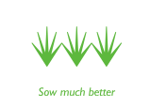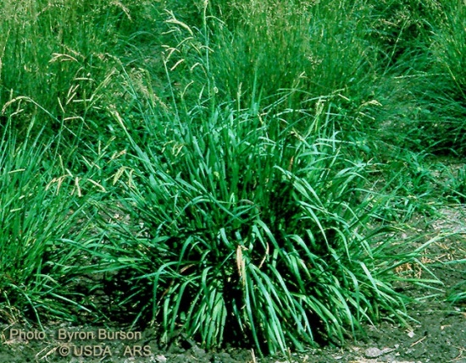 and the Weeran Angus specialist seed stock operation, but is also the venue for Upper Murray Seeds’ western district demonstration site and annual Field Day.

Head Office

Upper Murray Seeds Pty Ltd

1014A Nowra Street, Albury NSW 2640

Tel (02) 6040 6464, Fax (02) 6040 6470

Email [albury@uppermurrayseeds.com.au](mailto:albury@uppermurrayseeds.com.au)

ABN 96 079 215 384

Upper Murray Seeds’ team at Sheepvention will include sales agronomist Chris Harkness, who explains: “Our seed is bred to perform and persist in even the toughest conditions so our site at ‘Weerangourt’ gives locals a chance see how well Upper Murray Seeds’ varieties handle the western district climate.”

Weeran is a leading Angus herd producing high performance genetics, which are regularly proving their worth on farm and feedlot. These quality cattle are powered in part by consuming premium pasture produced from Upper Murray Seeds.

At Sheepvention you can talk to Weeran Angus principal, Jo Moore, and share some of the success strategies for their enterprise, including tips on bull selection and other specialities such as sourcing alternate feedstuffs.

Although not possible to exhibit any animals at Sheepvention, Weeran bulls go on show to the public at a Field Day at ‘Weerangourt’ on Wednesday 9 September, in the lead up to their spring bull sale on Tuesday 15 September when 50 two-year-old bulls will be offered at auction.

A great bonus for Sheepvention visitors will be the fabulous prizes on offer

at the Weeran Angus/Upper Murray Seeds Site 335 in Third Walk near the Ag Industry Inventions area. So come and see what’s on offer to help boost your bottom line through combining productive pasture and elite genetics. UMS and Weeran Angus look forward to seeing you on 3rd and 4th August at Sheepvention.

**ENDS**

**For more information:**

Chris Harkness, Upper Murray Seeds 0428 406464

[www.uppermurrayseeds.com.au](http://www.uppermurrayseeds.com.au)

Jo Moore, Weeran Angus 0429 787258

[www.weeranangus.com.au](http://www.weeranangus.com.au)

For media information:

Meredith Ashton 0409 377539